Team Foundation Version Control (TFVC)

In this chapter

* [About Team Foundation Version Control (TFVC) and Ranorex Studio](https://www.ranorex.com/#AboutTeamFoundationVersionControlTFVCandRanorexStudio)
* [Add a Ranorex Solution to TFVC](https://www.ranorex.com/#AddaRanorexSolutiontoTFVC)
* [Check out a Ranorex Solution from TFVC](https://www.ranorex.com/#CheckoutaRanorexSolutionfromTFVC)
* [Icon overlays in Projects View](https://www.ranorex.com/#IconoverlaysinProjectsView)
* [Options](https://www.ranorex.com/#Options)

About Team Foundation Version Control (TFVC) and Ranorex Studio

Team Foundation Version Control (TFVC) is a centralized version control system by Microsoft included in Team Foundation Server.

You will need to install the following software to work with TFVC in Ranorex Studio:

[Team Explorer 2013 for Visual Studio](https://my.visualstudio.com/Downloads?q=team%2520explorer) (Requires a free Microsoft account and Visual Studio Dev Essential subscription)

[MSSCCI Provider for Visual Studio 2013 & 2015](https://marketplace.visualstudio.com/items?itemName=TFSPowerToolsTeam.MicrosoftVisualStudioTeamFoundationServer20132015M)

Don’t worry about the 2013/2015 designations in the software names if you’re using later versions (e.g. 2017) of Visual Studio or TFS. They are compatible and the TFVC integration will work.

Ranorex Studio will assist you with this dialog in case the required software is not present on the machine:

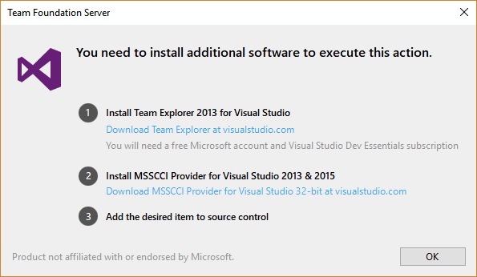

The MSSCCI interface supports [single byte character sets](http://msdn.microsoft.com/en-us/library/windows/desktop/dd374056%28v=vs.85%29.aspx) (SBCS) only. [Here](http://msdn.microsoft.com/en-us/library/hx842df0%28v=vs.71%29.aspx) you can find a description on how to change the code page. This means there is no [MBCS support](http://msdn.microsoft.com/en-us/library/cc194761.aspx).

Add a Ranorex Solution to TFVC

Please make sure your Team Foundation Server infrastructure is set up and working.

For adding an existing Ranorex Solution to TFVC open the context menu of the solution. Go to ‘Source Control’ and click on ‘Add Solution to Source Control’.

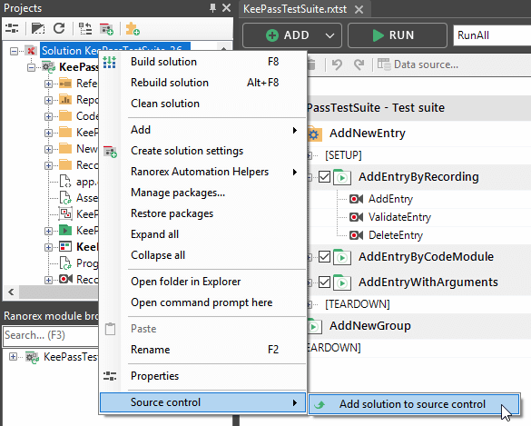

To add a new Ranorex Solution right from the beginning to TFVC check the option ‘Add to Source Control’ in the ‘New Project’ dialog.

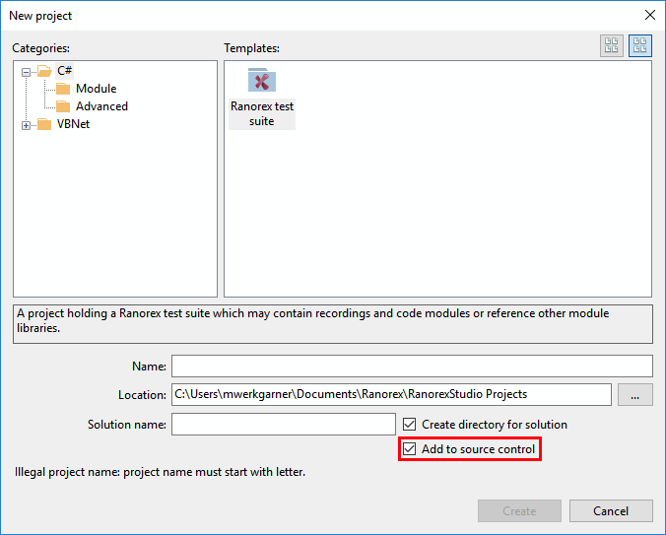

The ‘Source Control Wizard’ will be opened.

Please follow these instructions:

Choose ‘Microsoft Team Foundation Server’ as Source Control provider.

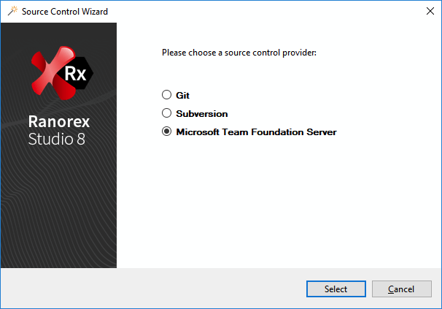

Select your Team Foundation Server.

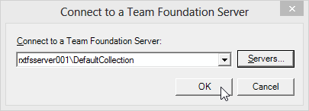

Choose the folder you want to add your solution to.

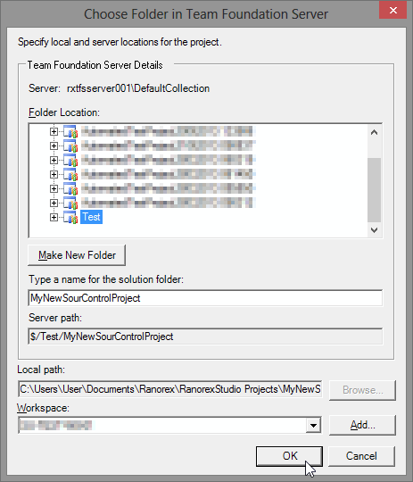

Select the files you want to have under source control and deselect the files you don’t want to have under source control respectively and perform a check in.

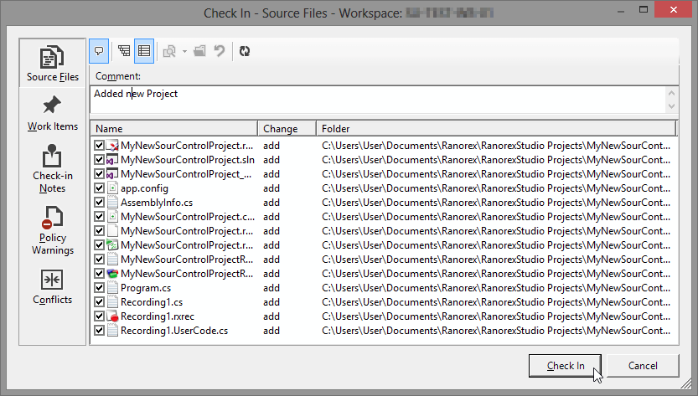

After performing these steps, your solution is under source control and your local copy is up to date.

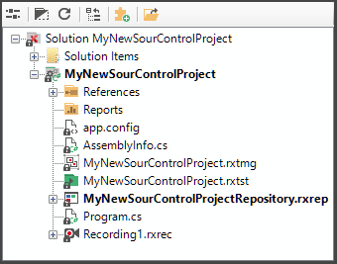

Check out a Ranorex Solution from TFVC

Please make sure your Team Foundation Server infrastructure is set up and working.

Open ‘Tools’ menu, move to ‘Source Control’ and click on ‘Checkout…’.

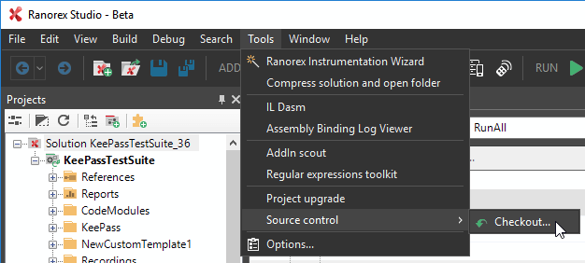

Choose ‘Microsoft Team Foundation Server’ as Source Control provider in Source Control Wizard.



Specify the local check out Directory

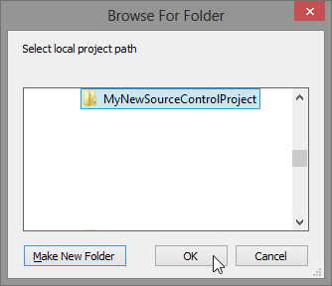

Select your Team Foundation Server.

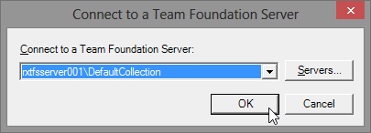

Choose the folder in the repository you want to check out from server.

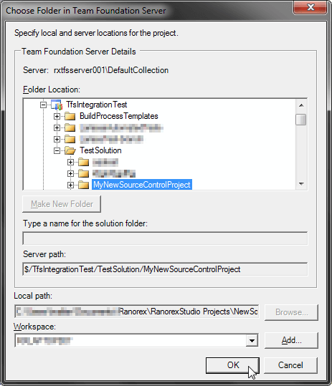

The chosen solution will be checked out.

Icon overlays in Projects View

Overlay icons are added to the items in the Projects view in Ranorex Studio as the solution is under source control.

|  |  |
| --- | --- |
| Icon overlays | |
| https://www.ranorex.com/rx-media/rx-user-guide/v8.2/E40/E4030-0000091.png Normal | File under source control, not checked out for editing. |
| https://www.ranorex.com/rx-media/rx-user-guide/v8.2/E40/E4010-0000120.png Conflicted | File under source control, checked out, not dirty. |
| https://www.ranorex.com/rx-media/rx-user-guide/v8.2/E40/E4010-0000140.png Modified | File under source control, checked out, dirty. |
| https://www.ranorex.com/rx-media/rx-user-guide/v8.2/E40/E4010-0000150.png Added | File added to project, not checked in. |

Options

In Ranorex Studio Options you can find options related to TFVC.

Open main menu item ‘Tools’ and choose ‘Options…’. In the following dialog select folder ‘Tools’ and sub-item ‘TFS Options’. By default, all checkboxes are checked.

If you are working with TFVC and running into performance problems with big solutions, uncheck ‘Enable file state ‘Modified’ check’.

